AVICENNA MEDICAL & DENTAL COLLEGE


STUDY GUIDE

2026

GIT & NUTRITION-1

BLOCK- 4 MODULE-6



Program: MBBS Integrated Curriculum
Year: 2nd Professional Year
Batch No: M-24
Session: 2025-2026

Table of Contents

About Avicenna Medical College 3
Message from the Principal 3
Message from the Chairman 4
Vision & Mission 5
List of Abbreviations 6
Introduction to the Study Guide 10
Objectives of the Study Guide 11
7-Star Doctor Competencies (PMDC) 12
Introduction to Module-6 13
Module Committee 14
Curriculum Map 16
Academic Calendar 17
Time Table: 18
Allocation of Hours 21
Module Outcome 22
Learning Objectives 24
Operational Definition 49
Assessment Policy 51
Assessment Criteria and Weighting 52
Assessment Procedures 52
Appeal Process 53
Attendance Requirement & Internal Assessment Criteria 53
Assessment Guidelines 53
Assessment Schedule: 55
Table of Specification 56
Recommended Books & Reading Resources 57
Infrastructure Resources 61

About Avicenna Medical College

Avicenna Medical & Dental College is a purpose-built, fully equipped institution with experienced and excellence-driven faculty to train high-quality dental professionals in Pakistan.
Avicenna Medical & Dental College runs under the umbrella of Abdul Waheed Trust. Abdul Wahid Trust is a non-profit social welfare organization and registered under the Societies Act with the Registrar of Societies. The Trust is legalized through a Trust Deed that bears necessary rectifications. The Trust Deed is further supported by its Memorandum and Article of Association that authorizes the establishment and operation of the Medical College, the Dental College, the Nursing College, the Allied Health Sciences College, and other activities in the healthcare sector.
In 2009, Avicenna Medical & Dental College was recognized by the Pakistan Medical & Dental Council. With the advent of advanced tools and technology in every field of health science, medicine today has shot up to the greater end of the gamut with superior choice and promises in medical therapy in the very vicinity of the common man. AVMDC promises to be one such neighborhood.



Message from the Principal

As a Co-Founder and Co-Chairperson, I have been involved in planning, construction and accreditation of Avicenna Medical College by the Pakistan Medical and Dental Council (PM&DC) and its affiliation with the esteemed University of Health Sciences (UHS). It is a pleasure to see Avicenna Medical College develop, progress and achieve maximum academic excellence in a short period since its inception in 2009. The institution has lived up to its mission of training and producing medical graduates of international standards. Three batches have passed out as Doctors, who currently are serving in the country and abroad while several have opted for post-graduation and are on road to progress. We have achieved several milestones since 2009 including the recognition of our College for FCPS training by College of Physicians and Surgeons of Pakistan (CPSP), establishment of College of Nursing and Avicenna Dental College.

Principal
Prof. Dr. Gulfreen Waheed
MBBS, FCPS, MHPE, PhD Scholar - HPE
Avicenna Medical & Dental Colleg

Message from the Chairman
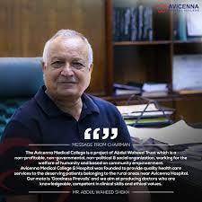

The Avicenna Medical & Dental College is a project of Abdul Waheed Trust which is a Non-profitable, Non-governmental, Non -political & Social organization, working for the welfare of Humanity and based on Community empowerment. Avicenna Medical College has its own 530 bedded Avicenna teaching Hospital (Not for Profit hospital) within the College Campus & 120 bedded Aadil Hospital, at 15 minutes’ distance. Separate comfortable hostels for boys & girls are provided on the campus.
Our students benefit from the state of the art College Library with facilities of Internet & online Journals that remain open 15 hours a day, for our students & faculty members. I am particularly pleased with the hard work by the Faculty and Students in the achievement of historic 100% results for all the classes. It is a rare achievement and speaks of dedication of the Faculty and Staff. Our motto is Goodness prevails and we aim at producing Doctors’ who are knowledgeable, competent in clinical skills and ethical values.
Avicenna Medical College & Hospital was founded to provide quality health care services to the deserving patients belonging to the rural areas near Avicenna Hospital as well as to provide quality medical education of international standard to our students. The Hospital provides all medical services and Lab diagnostics to the local population at minimal cost. So far by the grace of Allah Almighty the number of patients being treated and operated upon at our Hospital is increasing every day as there is no other public or charity hospital in the circumference of 20km. We have already established two Satellite Clinics in the periphery which are providing outdoor care while admission cases are brought to the Hospital in Hospital transport.
Following the success of our reputable Medical College and Hospital, we were able to successfully establish Avicenna Dental College which is recognized by the Pakistan medical & Dental Council & University of Health Sciences. To date, we have enrolled five batches in our dental college and we aim to achieve the same level of success for our dental students as our medical students.

Chairman
Abdul Waheed Sheikh
Avicenna Medical & Dental College

Vision & Mission
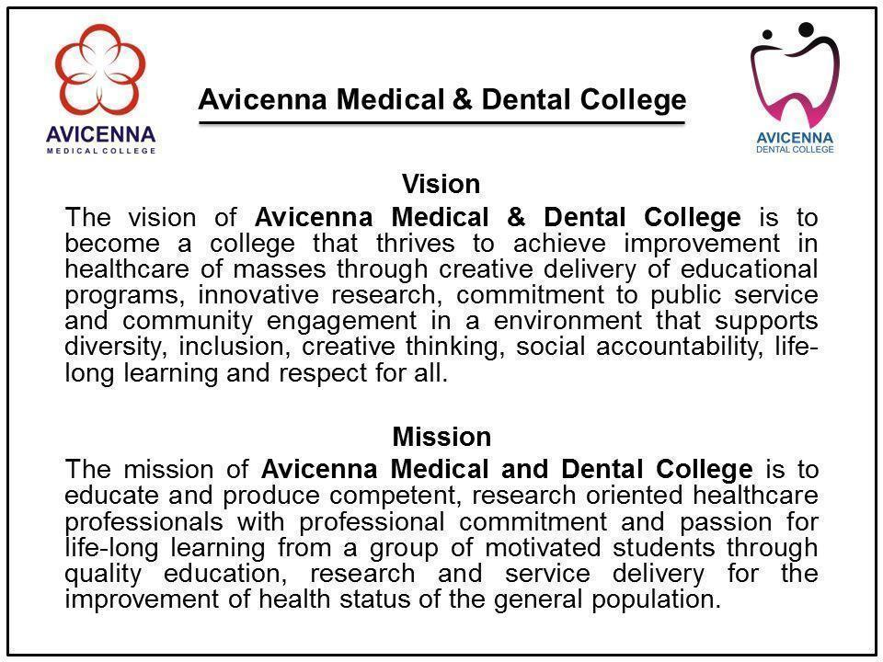

List of Abbreviations

Letter | Abbreviations | Subjects
A | A | Anatomy
A | ABCDE | Airway, Breathing, Circulation, Disability, Exposure
A | ABG | Arterial blood gas
A | ACS | Acute Coronary Syndromes
A | Ag | Aging
A | AKI | Acute kidney injury
A | ALT | Alanine transaminase
A | AMI | Acute Myocardial Infarction
A | AMP | Adenosine monophosphate
A | ANA | Antinuclear Antibody
A | ANCA | Anti-neutrophil Cytoplasmic Antibodies
A | ANS | Autonomic Nervous System
A | AO | Association of osteosynthesis
A | APTT | Activated Partial Thromboplastin Clotting Time
A | ARDS | Acute Respiratory Distress Syndrom
A | ARVC | Arrhythmogenic Right ventricular Cardiomyopathy
A | ASD | Atrial Septal Defect
A | AST | Aspartate aminotransferase
A | ATLS | Advanced Trauma Life Support
A | Au | Autopsy
A | AUC | Area under the curve
A | AV | Atrioventricular
B | B | Biochemistry
B | BhS | Behavioral Sciences
B | BHU | Basic Health Unit
B | BSL | Biological Safety Level
C | C | Civics
C | C-FRC | Clinical-Foundation Rotation Clerkship
C | C.burnetii | Clostridium burnetii
C | C.neoformans | Clostridium neoformans
C | C.pneumoniae | Clostridium pneumoniae
C | C.psittaci | Clostridium psittaci
C | C.trachomatis | Clostridium trachomatis
C | CA | cancer
C | CABG | coronary artery bypass grafting
C | CAD | coronary artery disease
C | CBC | Complete Blood Count
C | CCR5 | cysteine-cysteine chemokine receptor
C | CD31 | cluster of differentiation 31
C | CD34 | cluster of differentiation 34
C | CD4 | cluster of differentiation 4
C | CF | cystic fibrosis
C | CK | Creatine kinase
C | CLED | cystine lactose electrolyte deficient
C | CLL | chronic lymphocytic leukemia
C | CM | Community Medicine
C | CML | chronic myeloid leukemia
C | CMV | cytomegalo virus
C | CNS | Central Nervous System
C | CO | Carbon monoxide
C | CO2 | Carbon dioxide
C | CODIS | combined DNA index system
C | COPD | Chronic obstructive pulmonary disease
C | COVID-19 | Corona Virus Disease 2019
C | COX | Cyclooxygenase
C | CPR | Cardiopulmonary Resuscitation
C | CR | Clinical Rotation
C | CRP | Clinical Rotation CSF C- Reactive Protein
C | CSF | Cerebro Spinal Fluid
C | CT | Computed tomography
C | CV | Cardiovascular
C | CVA | Cerebral vascular accident
C | CVS | Cerebrovascular system
D | D.medinensis | Dracunculus Medinensis
D | DALY | Disability-Adjusted Life Year
D | DCIS | Ductal Carcinoma in situ
D | DCM | Dilated Cardiomyopathy Dorsal Colu
D | DCMLS | Dorsal column medial lemniscus system
D | DLC | Differential Leukocyte Count
D | DMARDs | Disease Modifying Anti Rheumatic Drugs
D | DNA | DeoxyRibonucleic Acid
D | DOTS | Directly Observed Treatment Short-course
D | DTP | Diphtheria, Tetanus, Pertussis
D | DVI | Disaster Victim Identification
D | DVT | Deep Vein Thrombosis
E | E.coli | Escherichia coli
E | ECF | Extracellular Fluid
E | ECG | Electrocardiography
E | ECP | Emergency contraceptive pills
E | ED50 | Median Effective Dose
E | EEG | Electroencephalogram
E | EIA | Enzyme Immunoassay
E | ELISA | Enzyme Linked Immunosorbent Assay
E | EnR | Endocrinology & Reproduction
E | ENT | Ear Nose Throat
E | EPI | Expanded Programme on Immunization
E | ER | Emergency Room
F | F | Foundation
F | FAST | Focused Assessment with Sonography
F | FEV1 | Forced Expiratory Volume 1
F | FM | Family Medicine
F | For | Forensic Medicine
F | FPIA | Fluorescent Polarization Immunoassay
F | FS | Forensic Serology
F | FSc | Forensic Science
F | FVC | Forced Vital Capacity
G | GCS | Glasgow Coma Scale
G | GFR | Glomerular Filtration Rate
G | GIT | Gastrointestinal tract
G | GL-MS | Gas Liquid Mass Spectrometry
G | GLC | Gas Liquid Chromatography
G | GLP | Guanosine Monophosphate
G | GMP | Guanosine monophosphate
G | GO | Gynecology and Obstetrics
G | GP | General Practitioner
G | GPE | General Physical Examination
G | GTO | Golgi Tendon Organ
G | Gynae & Obs | Gynecology and Obstetrics
H | H & E | Hematoxylin and eosin
H | H. influenzae | Haemophilus influenzae
H | H.pylori | Helicobacter pylori
H | HAI | Healthcare Associated Infections
H | HbC | Hemoglobin C
H | HbS | Sickle Hemoglobin
H | HbSC | Hemoglobin Sickle C Disease
H | HCL | Hydrochloric Acid
H | HCM | Hypertrophic Cardiomyopathy
H | HHV | Human Herpesvirus
H | HIT | Hematopoietic, Immunity and Transplant
H | HIV | Human Immunodeficiency Virus
H | HL | Hematopoietic & Lymphatic
H | HLA | Human Leukocyte Antigen
H | HMP | Hexose Monophosphate
H | HNSS | Head & Neck and Special Senses
H | HPLC | High Pressure Liquid Chromatography
I | ICF | Intra Cellular Fluid
I | ID | Infectious Diseases
I | IE | Infective Endocarditis
I | IL | Interleukin
I | ILD | Interstitial Lung Disease
I | IN | Inflammation
I | INR | International Normalized Ratio
I | INSTIs | ntegrase Strand Transfer Inhibitors
I | IPV | Intrauterine Device
I | IUD | Intrauterine device
I | IUGR | Intra-Uterine Growth Restriction
J | JVP | Jugular Venous Pulse
L | L | Law
L | LD50 | Median Lethal Dose
L | LDH | Lactate Dehydrogenase
L | LSD | Lysergic acid diethylamide
M | M | Medicine
M | MALT | Mucosa Associated Lymphoid Tissue
M | MBBS | Bachelor of Medicine, Bachelor of Surgery
M | MCH | Mean corpuscular hemoglobin
M | MCHC | Mean Corpuscular Hemoglobin Concentration
M | MCV | Mean Corpuscular Volume
M | MHO2001 | Mental Health Ordinance 2001
M | MoA | Mechanism of action
M | MRI | Mechanism of action
M | MS | Musculoskeletal
M | MSD | Musculoskeletal disorders
M | MSDS | Minimum Service Delivery Standards
M | MSK | Musculoskeletal
N | N | Neoplasia
N | NEAA | Non-Essential Amino Acids
N | NK cells | Natural Killer Cells
N | NNRTI | Non-nucleoside Reverse Transcriptase Inhibitors
N | NRTIs | Nucleoside Reverse Transcriptase Inhibitors
N | NS | Neurosciences
N | NSAIDs | Non-steroidal Anti-Inflammatory Drugs
O | O | Ophthalmology
O | OA | Osteoarthritis
O | OPC | Organophosphate
O | OPV | Oral poliovirus vaccine
O | Or | Orientation
O | Orth | Orthopaedic
P | P | Physiology
P | P.jiroveci | Pneumocystis jiroveci
P | Pa | Pathology
P | PAD | Pathology
P | PAF | Platelet activating factor
P | PBL | Problem Based Learning
P | PCH | Psychiatry
P | PCR | Polymerase Chain Reaction
P | PDA | Patent Ductus Arteriosus
P | PDGF | Platelet derived growth factor
P | Pe | Pediatrics
P | PEM | Protein Energy Malnutrition
P | PERLs | Professionalism, Ethics,Research, Leadership
P | PET | Positron Emission Tomography
P | Ph | Pharmacology
P | Ph | Pharmacology
P | PI | Personal Identity
P | PID | Pelvic inflammatory disease
P | Pls | Protease in hibitors
P | PMC | Pakistan Medical Commission
P | PMDC | Pakistan Medical and Dental Council
P | PMI | Post-Mortem Interval
P | PNS | Peripheral Nervous System
P | PPD | Paraphenylenediamine
P | PPE | Personal Protective Equipment
P | Psy | Psychiatry
P | PT | Prothrombin Time
P | PVC | Premature Ventricular Contraction
P | PVD | Peripheral Vascular Diseases
Q | QALY | Quality-Adjusted Life Year
Q | QI | Quran and Islamiyat
R | R | Renal
R | Ra | Radiology
R | RA | Radiology
R | RBCs | Red Blood cells
R | RCM | Restrictive Cardiomyopathy
R | RDA | Recommended Dietary Allowance
R | Re | Respiratory
R | RF | Rheumatoid factor
R | RFLP | Restriction Fragment Length Polymorphism
R | Rh | Rheumatology
R | RHC | Rural Health Center
R | RIA | Radioimmunoassay
R | RMP | Resting Membrane Potential
R | RNA | Ribonucleic Acid
R | RTA | Road Traffic Accident
S | S | Surgery
S | S.pneumonia | Streptococcus pneumoniae
S | SA | Sinoatrial
S | SCC | Squamous-cell carcinoma
S | Se | Sexology
S | Sec | Section
S | SIDS | Sudden Infant Death Syndrome
S | SLE | Systemic Lupus Erythematosus
S | SOP | Standard Operating Procedure
T | TB | Tuberculosis
T | TBI | Traumatic Brain Injury
T | TCA | Tricarboxylic acid cycle
T | TCBS | Thiosulphate Citrate Bile salts Sucrose
T | TD50 | Median Toxic Dose
T | TGA | Transposition of the Great Arteries
T | Th | Thanatology
T | TLC | Thin Layer Chromatography
T | TNF | Tumor Necrotic Factor
T | TNM | Tumor Necrotic Factor
T | TOF | Tetralogy of Fallot
T | Tox | Toxicology
T | Tr | Traumatology
T | TSI | Triple Sugar Iron
U | USG | Ultrasonography
U | UTI | Urinary Tract Infections
U | UV | Ultraviolet
V | VAP | Ventilator-Associated Pneumonia
V | Vd | Volume of Distribution
V | VEGF | Vascular Endothelial Growth Factor
V | VSD | ventricvular septal defect
W | W. bancroft | Wuchereria bancroft
W | WBCs | White Blood Cells
W | WHO | World Health Organization
Z | ZN Staining | Ziehl-Neelsen Staining

Introduction to the Study Guide
Welcome to the Avicenna Medical & Dental College Study Guide!
This guide serves as your essential resource for navigating the complexities of your medical education at Avicenna Medical & Dental College. It integrates comprehensive details on institutional framework, curriculum, assessment methods, policies, and resources, all meticulously aligned with UHS, PMDC and HEC guidelines.
Each subject-specific study guide is crafted through a collaborative effort between the Department of Medical Education and the respective subject departments, ensuring a harmonized and in-depth learning experience tailored to your academic and professional growth.

Objectives of the Study Guide

- Institutional Understanding:
  - Gain insight into the college’s organizational structure, vision, mission, and graduation competencies as defined by PMDC, setting the foundation for your educational journey.
- Effective Utilization:
  - Master the use of this guide to enhance your learning, understanding the collaborative role of the Department of Medical Education and your subject departments, in line with PMDC standards.
- Subject Insight:
  - Obtain a comprehensive overview of your courses, including detailed subject outlines, objectives, and departmental structures, to streamline your academic planning.
- Curriculum Framework:
  - Explore the curriculum framework, academic calendar, and schedules for clinical and community rotations, adhering to the structured guidelines of UHS & PMDC.
- Assessment Preparation:
  - Familiarize yourself with the various assessment tools and methods, including internal exam and external exam criteria, and review sample papers to effectively prepare for professional exams.
- Policies and Compliance:
  - Understand the institutional code of conduct, attendance and assessment policies, and other regulations to ensure adherence to college standards and accrediting body requirements.
- Learning Resources:
  - Utilize the learning methodologies, infrastructure resources, and Learning Management System to maximize your educational experience and academic success.
This guide, meticulously developed in collaboration with your subject departments, is designed to support your academic journey and help you achieve excellence in accordance with the highest standards set by PMDC and HEC.

7-Star Doctor Competencies (PMDC)

According to national regulatory authority PMDC, a Pakistani medical/dental graduate who has attained the status of a 'seven-star doctor’ is expected to demonstrate a variety of attributes within each competency. These qualities/ generic competencies are considered essential and must be exhibited by the individual professionally and personally.

- Skillful / Care Provider.
- Knowledgeable / Decision Maker.
- Community Health Promoter / Community Leader.
- Critical Thinker / Communicator
- Professional / Lifelong learner.
- Scholar / Researcher
- Leader/ Role Model / Manager

Introduction to Module-6
- The module 6 is designed to build upon and consolidate the foundational knowledge acquired in the earlier years of medical education, particularly from the Foundation-I module.

- As students transition into their clinical years, it is crucial to reinforce and deepen their understanding of basic medical sciences to support the integration of new, clinically relevant concepts.

- This module serves as a bridge, revisiting core topics in general Pharmacology, Pathology, and Forensic medicine with an emphasis on their clinical applications.

- By doing so, it ensures that students develop a more comprehensive understanding, which is vital for the advanced study of organ systems in subsequent modules (e.g., CVS 2, Respiratory-2, GIT-2, Neurosciences-2, and Reproduction 2).

- Mastery of these topics is essential before students can effectively approach the complexities of clinical scenarios.

- The revisiting of these concepts throughout the curriculum ensures a robust and integrated understanding, laying a solid foundation for clinical competence.

Module Committee

Name | Designation | Department
Prof. Dr. Gulfreen Waheed | Principal & Director DME | Medical Education
Dr. Saba Iqbal | Associate Professor | Medical Education
Dr. Syed Hussain Raza | Assistant Professor | Medical Education
Dr. Ijlal Zehra | HOD | Assessment Cell
Dr. Javaid Shabkhez Rab | Coordinator | Medical Education
Dr. Huma Fatima | Demonstrator | Medical Education
Mr. Adeel | Incharge | Student Affairs
Prof. Dr. Razia | HOD | Anatomy
Dr. Kalsoom | Focal Person | Anatomy
Prof. Dr. Sadia Zafer | HOD | Physiology
Dr. Shaheena | Focal Person | Physiology
Prof. Sadia Amir | HOD | Biochemistry
Dr. Yusra | Focal Person | Biochemistry
Prof. Dr. Saeed Afzal | HOD | Pathology
Dr. Nadia salam | Focal Person | Pathology
Prof. Dr. Asma Saeed | HOD | Pharmacology
Dr. Azka | Focal Person | Pharmacology
Prof. Dr.Rana Akhtar | HOD | Community Medicine
Dr. Sana | Focal Person | Community Medicine
Dr. Uzma | Focal Person | General Surgery
Prof. Dr. Muzammil | HOD | Medicine Unit-1
Dr. Asim | Focal Person | General Medicine
Dr. Farhat Mihas | HOD | Behavioural Sciences

Curriculum Map

This pictorial, vertical and horizontal presentation of the course content and extent shows the sequence in which various systems are to be covered. Curricular map to cover all the subjects and modules and the time allocated to study of the systems for the undergraduate programs offered at four colleges at campus are as follows:

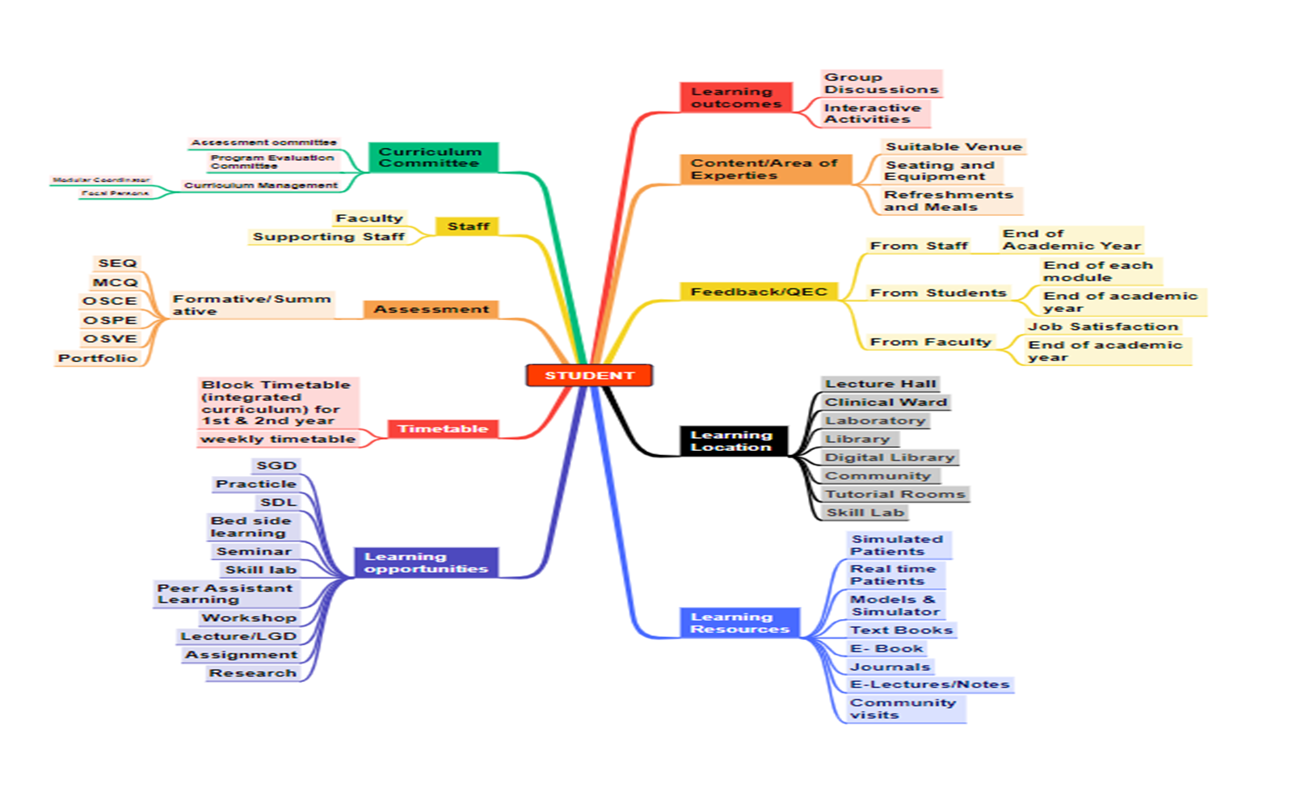

Academic Calendar
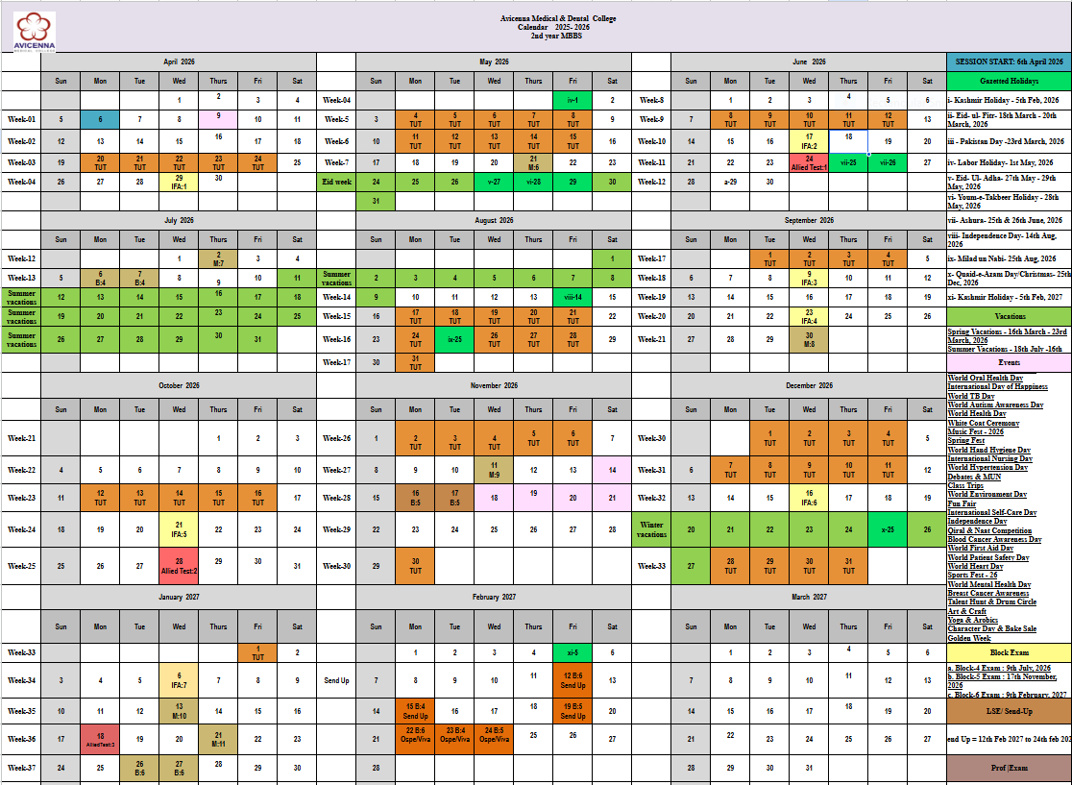

Time Table:
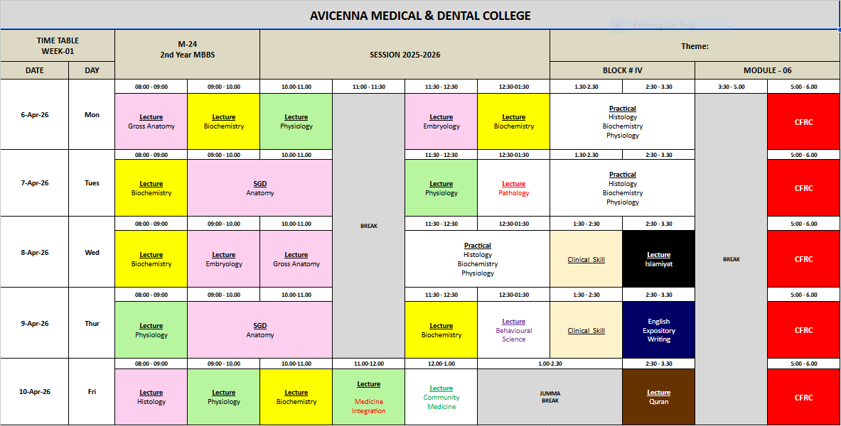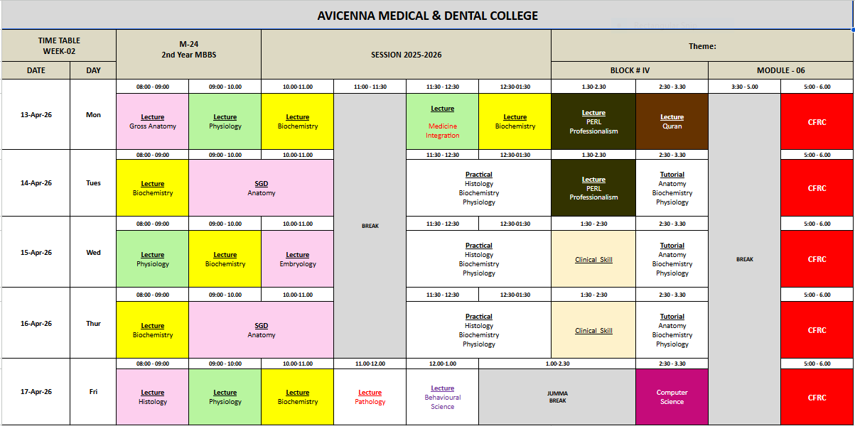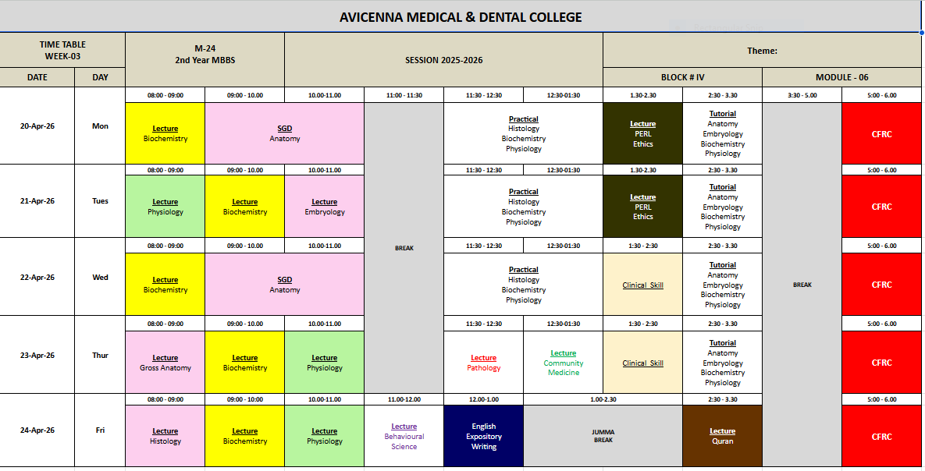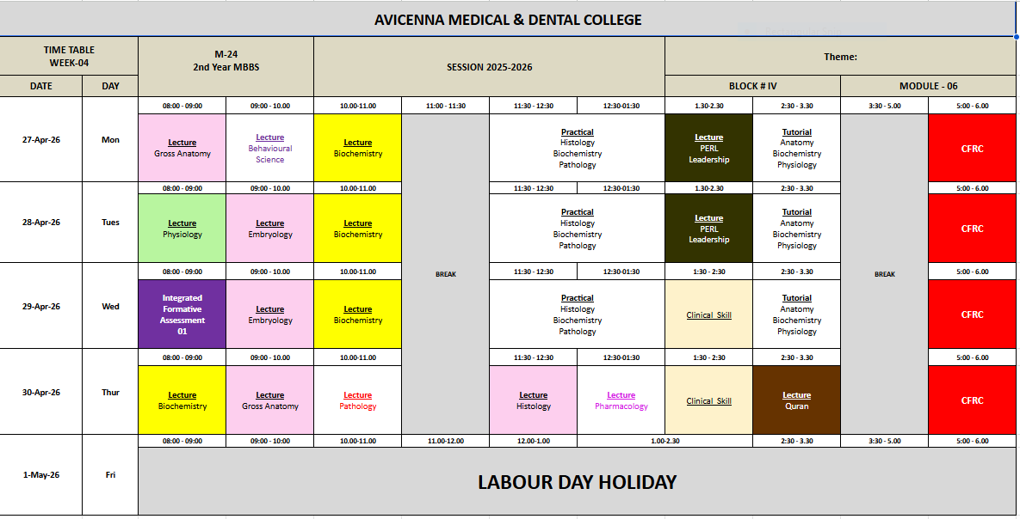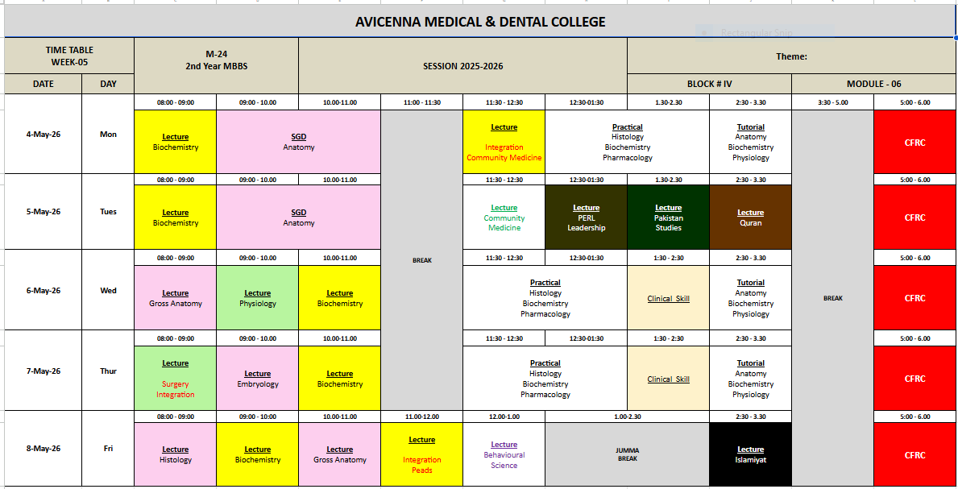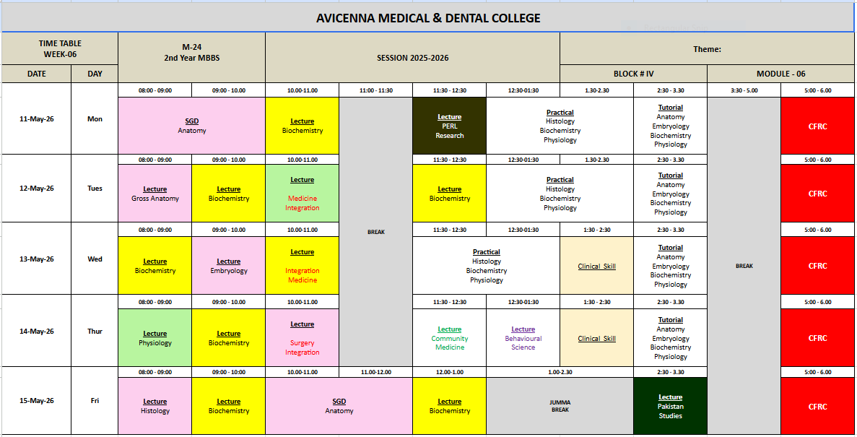

Allocation of Hours
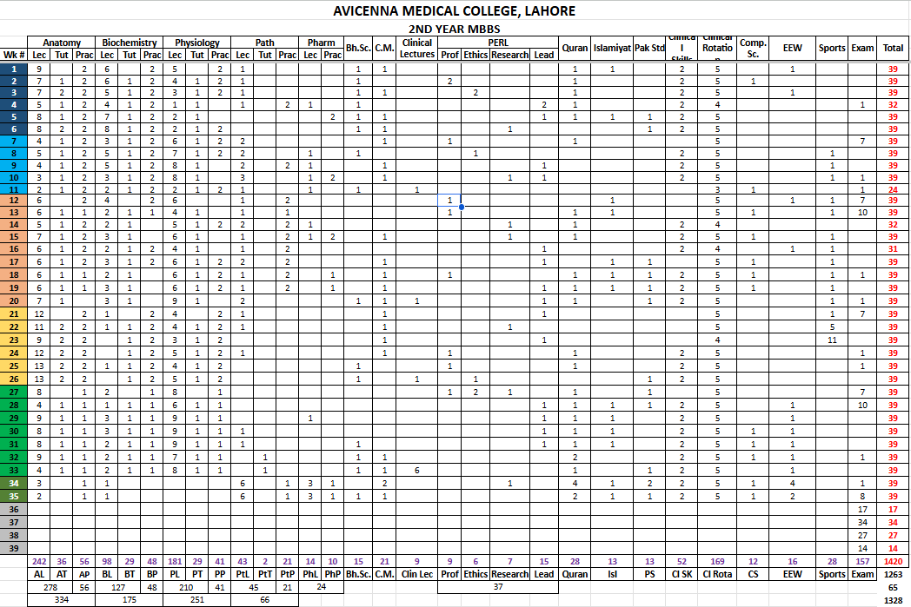

Module Outcome
- Describe the microscopic features of nerve cells, muscle cells, general features of epithelia of the body.
- Appraise the functional characteristics of various components of cell membrane and organelles of cell.
- Differentiate between the dynamics of various transport mechanisms along the cell membrane.
- Compare the functional differences between RBCs, WBCs and blood groups.
- Explain the significance of homeostatic mechanisms in keeping the body's internal environment nearly constant.
- Appraise the formation and functions of the autonomic nervous system.
- Correlate the structural design of each organ to its function.
- Acquire information about the different fascial planes in the different regions of the body & their surgical importance.
- Use descriptive anatomical terms of position to describe the different body structures in relation to each other.
- Describe the movements of body using proper anatomical terms of movement.
- Describe and demonstrate the various bony landmarks.
- Describe the types of joints and correlate them to the mechanisms of movement.
- Classify the bone, joints and muscles based on the structure, function, phylogenetic origin.
- Describe the structures associated with muscles and explain their functional correlations.
- Classify and describe the cardiovascular system and correlate it functionally.
- Amplify the anatomical basis for radiological, cross-sectional, anatomy.
- Correlate clinicopathologically the apoptosis in health & diseases

MODULE OUTCOMES
- To describe gross and microscopic anatomy of different parts of gastrointestinal system and associated organs
- To describe the embryological development of different parts of gastrointestinal system and associated organs
- To describe the functional anatomy and physiology of different parts of gastrointestinal system and associated organs
- To describe the motility, secretory and digestive function of gastrointestinal system
- To describe the biochemical aspects of carbohydrate metabolism
- To discuss pathological aspect and management of gastrointestinal related diseases
- To discuss the pharmacological treatment of diarrhea
- To discuss the psychosocial impact of gastrointestinal diseases in society
- To discuss the preventive measures related to gastrointestinal diseases
- To comprehend concept of balanced diet and malnutrition

Learning Objectives

NORMAL STRUCTURE
GROSS ANATOMY
CODE | SPECIFIC LEARNING OUTCOMES | TOTAL HOURS = 35
CODE | SPECIFIC LEARNING OUTCOMES | DISCIPLINE | TOPIC
GIT-A-001 | Describe the gross anatomical features of oral cavity with  its neurovascular supply and lymphatic drainage | Human Anatomy | Oral Cavity
GIT-A-001 | Discuss the location, anatomical features, relations and  vascular supply of tonsils: nasopharyngeal, palatine and lingual. | Human Anatomy | Oral Cavity
GIT-A-001 | Discuss the skeletal framework of hard palate with its  neurovascular supply and lymphatic drainage | Human Anatomy | Oral Cavity
GIT-A-001 | Describe the gross anatomical features of soft palate with  its neurovascular supply and lymphatic drainage | Human Anatomy | Oral Cavity
GIT-A-001 | Describe the attachments, nerve supply and actions of  muscles of soft palate | Human Anatomy | Oral Cavity
GIT-A-001 | Describe the structure of tongue with attachments of muscles, blood supply, nerve supply and lymphatic drainage.  Discuss the anatomical basis of injury to hypoglossal nerve | Human Anatomy | Oral Cavity
GIT-A-001 | Describe anatomical features, relations and neurovascular  supply of parotid gland and its duct, mentioning the structures entering and exiting the gland. | Human Anatomy | Oral Cavity
GIT-A-001 | Discuss the clinical correlates of parotid gland: parotiditis,  Mumps, Frey’s syndrome, parotid duct injury and parotid tumor surgery with its complications. | Human Anatomy | Oral Cavity
GIT-A-001 | Describe the Waldeyer’s ring. | Human Anatomy | Oral Cavity
GIT-A-001 | Describe anatomical features, relations and neurovascular  supply of submandibular and sublingual glands with their ducts. | Human Anatomy | Oral Cavity
GIT-A-002 | Describe the planes and quadrants of abdomen | Human Anatomy | Anterior Abdomen Wall
GIT-A-002 | Draw and label the cutaneous innervation and  dermatomes of anterior abdominal wall and anterolateral Abdominal wall and describe the clinical correlates | Human Anatomy | Anterior Abdomen Wall

(Abdominal pain, Muscle rigidity, Referred pain, anterior
abdominal nerve block)
Describe the fascia of anterior abdominal wall with its clinical significance
Describe anterolateral Abdominal wall arteries, Veins and Lymphatics and related clinical correlates—Caput Medusae
Describe the attachments, nerve supply and actions of
muscles of anterior abdominal wall
Identify the muscles of anterolateral abdominal wall on
anatomical model and/or cadaver
Describe the extent, formation and contents of rectus
sheath
 | Give the formation and extent of inguinal ligament
Describe the formation of superficial and deep inguinal
rings and conjoint tendon
Locate the position of superficial and deep inguinal rings
on simulated subject or Cadaver
Describe the extent, boundaries and contents of inguinal
canal
Define the following hernias: umbilical, epigastric,
incisional, Spigelian, lumbar, femoral, internal and inguinal
 | Differentiate between direct and indirect inguinal hernias
 | Describe the location of abdominal surgical incisions
Mark the abdominal incisions on simulated patient/ subject
and explain their anatomical basis
 | List the structures and coverings of spermatic cord
GIT-A-004 | Trace the horizontal and vertical peritoneal reflections | Human Anatomy | Peritoneum
GIT-A-004 | Describe the relationship of viscera to the peritoneum | Human Anatomy | Peritoneum
GIT-A-004 | Describe the gross anatomical features of the following:  1. Mesentery  2. Omentum  3. Peritoneal ligaments | Human Anatomy | Peritoneum

4. Peritoneal fold
5. Peritoneal sac,
6. Recesses,
7. Spaces and
8. Gutters
 | Describe the nerve supply of Peritoneum
Describe the anatomical basis and manifestations of the following:
1. Peritonitis and ascites
2. Peritoneal adhesions (and adhesiostomy)
3. Abdominal paracentesis
GIT-A-005 | Describe the extent of esophagus, its constrictions, neurovascular supply and lymphatic drainage  Discuss the anatomical basis of esophageal varices, achalasia and Gastro Esophageal Reflux Disease (GERD) |  | Esophagus
GIT-A-006 | Describe the location, position, parts, external and internal structure, relations, vascular and nerve supply and  lymphatic drainage of stomach | Human Anatomy | Stomach
GIT-A-006 | Draw and label a diagram illustrating the lymphatic  drainage of Stomach | Human Anatomy | Stomach
GIT-A-006 | Describe the clinical presentation and the anatomical basis and manifestations of the following conditions:  Carcinoma of stomach and peptic ulcers | Human Anatomy | Stomach
GIT-A-006 | Identify and demonstrate the parts, external and internal  features of stomach on anatomical model and cadaver | Human Anatomy | Stomach
GIT-A-007 | Describe the location, position, parts, relations, neurovascular supply and lymphatic drainage of  duodenum, Jejunum & Ileum (Small Intestine) | Human Anatomy | Small & Large Intestine
GIT-A-007 | Describe the anatomical basis and manifestations of the following conditions:  1. Duodenal Ulcers  2. Ileal diverticulum  3. Diverticulosis | Human Anatomy | Small & Large Intestine

4. Large bowel cancer
5. Appendicitis
6. Volvulus
7. Intussusception
 | Demonstrate the various positions of appendix
Identify and demonstrate the Parts and external features of small and large intestines on anatomical model and
cadaver
GIT-A-008 | Describe the origin, course, branches (tributaries in case  of veins) and distribution of the blood vessels of GIT | Human Anatomy | Liver
GIT-A-008 | Describe the formation, tributaries and drainage of hepatic-  portal vein | Human Anatomy | Liver
GIT-A-008 | Discuss the sites and vessels contributing in portosystemic  anastomosis | Human Anatomy | Liver
GIT-A-008 | Describe the clinical picture and anatomical basis for the  blockage of porto-systemic anastomosis | Human Anatomy | Liver
GIT-A-008 | Identify the blood vessels supplying GIT on anatomical  model and cadaver | Human Anatomy | Liver
GIT-A-008 | Describe location, lobes, important relations, peritoneal ligaments, blood supply, lymphatic drainage, nerve supply,  related clinical correlates of liver and subphrenic spaces. | Human Anatomy | Liver
GIT-A-009 | Describe components of Biliary tree- hepatic duct and bile  duct | Human Anatomy | Biliary System
GIT-A-009 | Describe relations, functions, blood supply, lymphatic  drainage and nerve supply of Gallbladder | Human Anatomy | Biliary System
GIT-A-009 | Describe related clinical correlates- gall stones, biliary  colic, cholecystectomy, gallbladder gangrene | Human Anatomy | Biliary System
GIT-A-010 | Describe the location, surfaces, peritoneal reflections, relations, neurovascular supply and lymphatic drainage of  pancreas | Human Anatomy | Pancreas
GIT-A-010 | Describe the anatomical basis and manifestations of  pancreatitis and pancreatic cancer | Human Anatomy | Pancreas
GIT-A-010 | Identify the parts of the pancreas | Human Anatomy | Pancreas

GIT-A-011 | Describe the location, surfaces, peritoneal reflections,  relations, neurovascular supply and lymphatic drainage of spleen | Human Anatomy | Spleen
GIT-A-011 | Describe the anatomical basis and manifestations of  splenic trauma and splenomegaly | Human Anatomy | Spleen
GIT-A-011 | Identify the borders, surfaces and Impressions of spleen | Human Anatomy | Spleen
GIT-A-011 | Demonstrate the correct anatomical positioning of spleen | Human Anatomy | Spleen
GIT-A-012 | Describe the gross anatomical features, peritoneal relations, blood supply, nerve supply and lymphatic drainage of cecum ascending and descending colon,  sigmoid colon, rectum and anal canal | Human Anatomy | Sigmoid Colon,  Rectum & Anal Canal
GIT-A-012 | Describe the anatomical basis for Sigmoidoscopy, rectal prolapse, rectal examination, rectal cancer and  hemorrhoids | Human Anatomy | Sigmoid Colon,  Rectum & Anal Canal
GIT-A-013 | Outline the anatomical basis and surgical treatment plan for the following diseases:  1. Esophageal Injuries  2. Gastric Carcinoma  3. Intestinal Obstruction  4. Pancreatic Carcinoma  5. Obstructive Jaundice  6. Gall Stones | Human Anatomy integrated with Surgery | Surgical Intervention
EMBRYOLOGY & POSTNATAL DEVELOPMENT
CODE | SPECIFIC LEARNING OUTCOMES | TOTAL HOURS = 08
CODE | SPECIFIC LEARNING OUTCOMES | DISCIPLINE | TOPIC
GIT-A-014 | Describe the development of tongue | Embryology | Oral Cavity
GIT-A-014 | Describe the embryological basis of tongue tie | Embryology | Oral Cavity
GIT-A-014 | Describe the development of palate | Embryology | Oral Cavity
GIT-A-014 | Describe the embryological basis of various facial clefts | Embryology | Oral Cavity
GIT-A-014 | Identify the parts of the developing tongue and palate | Embryology | Oral Cavity
GIT-A-015 | Describe the formation and divisions of gut tube  Describe the molecular regulation of gut tube development. | Embryology | Foregut

 | Describe the development of mesenteries
 | Describe the development of esophagus
Describe the embryological basis of esophageal atresia
and/or tracheoesophageal fistula
 | Describe the development and rotation of stomach
 | Describe the embryological basis of pyloric stenosis
Describe the development of duodenum, liver and gall bladder.
Describe the molecular regulation of liver.
Describe the embryological basis of intrahepatic and
extrahepatic biliary atresia
 | Describe the development of pancreas. Describe the molecular regulation of pancreas.
 | Describe the embryological basis of annular pancreas
GIT-A-016 | Describe the development of midgut especially mentioning physiological herniation, rotation, retraction of herniated  loops and mesenteries of the intestinal loops | Embryology | Midgut
GIT-A-016 | Describe the embryological basis of the following  1. mobile cecum  2. volvulus  3. retro colic hernia  4. Omphalocele  5. gastroschisis | Embryology | Midgut
GIT-A-016 | Describe the embryological basis of Meckel’s diverticulum | Embryology | Midgut
GIT-A-016 | Describe the embryological basis of;  1. Gut rotation defects  2. Gut atresia and stenosis | Embryology | Midgut
GIT-A-017 | Describe the development of hindgut | Embryology | Hindgut
GIT-A-017 | Describe the embryological basis of;  3. Rectourethral and rectovaginal fistulas  4. Recto anal fistulas and atresia  5. Imperforate anus  6. Congenital megacolon | Embryology | Hindgut
GIT-A-017 | Identify the parts of the developing foregut, midgut and  hindgut originating from the endoderm | Embryology | Hindgut

MICROSCOPIC ANATOMY (HISTOLOGY & PATHOLOGY)
CODE | SPECIFIC LEARNING OUTCOMES | TOTAL HOURS = 07
CODE | SPECIFIC LEARNING OUTCOMES | DISCIPLINE | TOPIC
GIT-A-018 | Describe the light microscopic structure of;  1. Lips  2. Tongue including lingual papillae and taste buds  3. Oral Cavity (Cheeks, Teeth gums, hard & Soft palate)  Describe the histological structure of parotid, submandibular and sublingual glands.  Compare and contrast the histological structures of parotid, submandibular and sublingual glands.  Describe the serous and mucous acini and give histological differences between the two.  Describe the structure and location of serous demilunes. Describe histology of oropharynx | Histology | Oral Cavity & Esophagus
GIT-A-018 | Relate the characteristics of various layers of GIT with their  function | Histology | Oral Cavity & Esophagus
GIT-A-018 | Describe the light microscopic structure of esophagus | Histology | Oral Cavity & Esophagus
GIT-A-018 | Tabulate the histological differences between different  parts of esophagus | Histology | Oral Cavity & Esophagus
GIT-A-018 | Describe the histological changes associated with reflux esophagitis and Barrett’s esophagus | Histology | Oral Cavity & Esophagus
GIT-A-019 | Describe the light microscopic structure of stomach | Histology | Stomach
GIT-A-019 | Describe the role of parietal cells in pernicious anemia | Histology | Stomach
GIT-A-020 | Describe the light microscopic structure of  1. Duodenum  2. Jejunum  3. Ileum | Histology | Small Intestine
GIT-A-020 | Discuss the histological basis of celiac disease | Histology | Small Intestine
GIT-A-020 | Discuss the histological basis of Crohn’s disease | Histology | Small Intestine

GIT-A-021 | Describe the light microscopic structure of  1. Colon  2. Appendix  3. Rectum  Define colorectal cancer, anal abscess, hemorrhoids | Histology | Large Intestine
GIT-A-022 | Describe the light microscopic structure of:  1. Liver  2. Gall Bladder  3. Pancreas | Histology | Accessory Organs
NORMAL FUNCTION
MEDICAL PHYSIOLOGY
CODE | SPECIFIC LEARNING OBJECTIVES | TOTAL HOURS = 20
CODE | SPECIFIC LEARNING OBJECTIVES | DISCIPLINE | TOPIC
GIT-P-001 | Classify the components of enteric nervous system | Medical Physiology | General Principles of GIT Function  - Motility, Nervous Control & Blood Flow
GIT-P-001 | Discuss the location and significance of myenteric plexus | Medical Physiology
GIT-P-001 | Describe the Meissner’s plexus | Medical Physiology
GIT-P-001 | Differentiate between myenteric and Meissner’s plexuses | Medical Physiology
GIT-P-001 | Explain the mechanism of developing slow wave | Medical Physiology
GIT-P-001 | Explain the mechanism of developing spike potential | Medical Physiology
GIT-P-001 | Enlist the factors that depolarize & hyperpolarize the GIT  membrane | Medical Physiology
GIT-P-001 | Enlist the excitatory & inhibitory neurotransmitters of  enteric nervous system | Medical Physiology
GIT-P-001 | Explain the role of sympathetic & parasympathetic nervous  system in controlling GIT function. | Medical Physiology
GIT-P-001 | Enlist the gastrointestinal reflexes & explain the functions  of these reflexes | Medical Physiology
GIT-P-001 | Enlist the hormones acting on GIT, their stimuli, site of  release and actions | Medical Physiology
GIT-P-001 | Enumerate different types of movements that occur in GIT | Medical Physiology
GIT-P-001 | Discuss the functions and control of GIT movements | Medical Physiology

Discuss the effect of gut activity and metabolic factors on
GIT blood flow / Splanchnic circulation
 | Explain the nervous control of GIT blood flow / Splanchnic circulation
GIT-P-002 | Trace the reflex arc of mastication | Medical Physiology | Oral Cavity & Esophagus
GIT-P-002 | Explain the process and importance of chewing reflex | Medical Physiology | Oral Cavity & Esophagus
GIT-P-002 | Enlist the stages of swallowing | Medical Physiology | Oral Cavity & Esophagus
GIT-P-002 | Describe the mechanism of voluntary stage of swallowing | Medical Physiology | Oral Cavity & Esophagus
GIT-P-002 | Trace the reflex arc of involuntary stage of swallowing | Medical Physiology | Oral Cavity & Esophagus
GIT-P-002 | Enlist the steps involved in involuntary stage of swallowing | Medical  Physiology | Oral Cavity & Esophagus
GIT-P-002 | Explain the effect of swallowing on respiration | Medical  Physiology | Oral Cavity & Esophagus
GIT-P-002 | Discuss the mechanism of esophageal stage of swallowing | Medical  Physiology | Oral Cavity & Esophagus
GIT-P-002 | Enlist causes of dysphagia | Medical Physiology integrates with  Surgery | Oral Cavity & Esophagus
GIT-P-002 | Explain the types and role of different peristalsis originating  in esophagus | Medical Physiology | Oral Cavity & Esophagus
GIT-P-002 | Discuss the role of Lower Esophageal Sphincter  (Gastroesophageal) | Medical Physiology | Oral Cavity & Esophagus
GIT-P-002 | Discuss the pathophysiology of achalasia &  Megaesophagus | Medical Physiology | Oral Cavity & Esophagus
GIT-P-002 | Enlist the features and treatment of achalasia | Medical  Physiology | Oral Cavity & Esophagus
GIT-P-003 | Explain storage function of stomach | Medical  Physiology | Stomach
GIT-P-003 | Describe the basic electrical rhythm of stomach wall | Medical  Physiology | Stomach
GIT-P-003 | Explain the role of pyloric pump and pyloric sphincter in  gastric emptying | Medical Physiology | Stomach
GIT-P-003 | Explain the factors that promote Stomach Emptying | Medical  Physiology | Stomach
GIT-P-003 | Discuss the duodenal (nervous & hormonal) factors that  inhibit Stomach emptying | Medical Physiology | Stomach
GIT-P-003 | Enlist the factors that initiate enterogastric inhibitory  reflexes | Medical Physiology | Stomach

 | Enumerate the causes, features, and pathophysiology of gastritis | Medical  Physiology integrates with Medicine
 | Explain the physiological basis of each feature of gastritis | Medical  Physiology integrates with Medicine
 | Recommend treatment of gastritis | Medical Physiology integrates with Medicine
 | Enumerate the causes, features, and pathophysiology of  peptic ulcer | Medical Physiology integrates with Medicine
 | Explain the physiological basis of each feature of peptic  ulcer | Medical Physiology integrates with Medicine
GIT-P-004 | Enumerate and explain the secretions and movements of  small intestine | Medical Physiology | Small Intestine
GIT-P-004 | Explain the term “peristaltic rush” | Medical Physiology | Small Intestine
GIT-P-004 | Explain the functions of ileocecal valve and sphincter | Medical Physiology | Small Intestine
GIT-P-004 | Enumerate the types of intestinal sprue | Medical Physiology integrates with Medicine | Small Intestine
GIT-P-004 | Enlist the features of intestinal sprue | Medical Physiology integrates with Medicine | Small Intestine
GIT-P-004 | Explain the consequences of sprue on the body | Medical Physiology integrates with Medicine | Small Intestine
GIT-P-005 | Enumerate the types of movements taking place in colon | Medical  Physiology | Large Intestine
GIT-P-005 | Explain the mechanism of developing movements of colon  and their control through Gastrocolic and Duodenocolic Reflexes | Medical Physiology | Large Intestine
GIT-P-005 | Enlist the defecation reflexes | Medical  Physiology | Large Intestine
GIT-P-005 | Explain the mechanism of defecation reflex | Medical  Physiology | Large Intestine
GIT-P-005 | Trace the reflex arc of defecation | Medical  Physiology | Large Intestine
GIT-P-005 | Name the other autonomic reflexes that affect bowel  activity | Medical Physiology | Large Intestine
GIT-P-005 | Explain the pathophysiology of constipation | Medical Physiology integrates with  Medicine | Large Intestine
GIT-P-005 |  | Medical  Physiology | Large Intestine

 | Describe the cause of Hirschsprung’s disease integrate with Medicine.
GIT-P-006 | Explain the functions of liver | Medical  Physiology | Liver
GIT-P-006 | Differentiate between liver and gall bladder bile and the  hormones acting on them | Medical Physiology | Liver
GIT-P-006 | Enumerate the causes and composition of developing gall stones | Medical Physiology Integrate with  Surgery | Liver
GIT-P-007 | Explain function and secretions of pancreas | Medical  Physiology | Pancreas
GIT-P-007 | Enlist the causes and pathophysiology of acute and  chronic pancreatitis | Integrate with Medicine | Pancreas
GIT-P-007 | Enumerate the features of acute pancreatitis and explain  the physiological basis of each feature of pancreatitis | Integrate with Medicine | Pancreas
GIT-P-008  . | Describe the stages of vomiting act | Medical  Physiology | Vomiting Reflex
GIT-P-008  . | Trace the reflex arc of vomiting | Medical  Physiology | Vomiting Reflex
GIT-P-008  . | Explain the role of chemoreceptor trigger zone for initiation  of vomiting by drugs or by motion sickness | Medical Physiology | Vomiting Reflex
GIT-P-009 | Define Acute Diarrhea | Integrated with Medicine Gastroenterology | Acute & Chronic Diarrhea
GIT-P-009 | Define Chronic Diarrhea | Integrated with Medicine Gastroenterology | Acute & Chronic Diarrhea
GIT-P-009 | Enlist various causes for acute and chronic diarrhea | Integrated with Medicine Gastroenterology | Acute & Chronic Diarrhea
BIOCHEMISTRY
CODE | SPECIFIC LEARNING OBJECTIVES | TOTAL HOURS = 40
CODE | SPECIFIC LEARNING OBJECTIVES | DISCIPLINE | TOPIC
GIT-B-001 | Give the composition and importance of saliva and related  clinical disorder (xerostomia) | Biochemistry | Biochemistry of GIT  /GIT  secretions & digestion and absorption of dietary carbohydrates
GIT-B-001 | Give the composition and importance of gastric juice with special reference to mechanism of HCl secretion and  related clinical disorders (achlorhydria, gastric ulcer | Biochemistry
GIT-B-001 | Give the composition and importance of pancreatic juice,  bile and succus entericus and related clinical disorders (pancreatitis, cystic fibrosis, cholelithiasis). | Biochemistry

Describe digestion and absorption of dietary
carbohydrates along with inherited and acquired disorders (lactose intolerance, sucrase-isomaltase deficiency).
GIT-B-002 | Elaborate key features of various transport systems for entry of glucose into cells. | Biochemistry | Carbohydrate metabolism/ Entry of glucose into  cells
GIT-B-003 | Enlist the hormones that play important roles in regulating  carbohydrate metabolism. | Biochemistry | Carbohydrate metabolism/ Hormonal control of BSL
GIT-B-003 | Elaborate the metabolic effects of these hormones. | Biochemistry | Carbohydrate metabolism/ Hormonal control of BSL
GIT-B-003 | Infer the consequences of deficiency and excess of these  hormones | Biochemistry | Carbohydrate metabolism/ Hormonal control of BSL
GIT-B-004 | Describe the glycolytic pathway along with its regulation  and significance. | Biochemistry | Carbohydrate metabolism/ Glycolysis
GIT-B-004 | Compare key features of aerobic and anaerobic glycolysis. | Biochemistry | Carbohydrate metabolism/ Glycolysis
GIT-B-004 | Calculate the number of ATP produced during aerobic and  anaerobic glycolysis. | Biochemistry | Carbohydrate metabolism/ Glycolysis
GIT-B-004 | Explain hemolytic anemia in subjects with pyruvate kinase  deficiency based on your biochemical knowledge. | Biochemistry | Carbohydrate metabolism/ Glycolysis
GIT-B-004 | Clearly differentiate between substrate level  phosphorylation and oxidative phosphorylation. | Biochemistry | Carbohydrate metabolism/ Glycolysis
GIT-B-005 | Discuss the metabolic fates of pyruvate. | Biochemistry | Carbohydrate metabolism/ Metabolic fates of pyruvate
GIT-B-005 | Describe the transport of pyruvate from cytosol to  mitochondria. | Biochemistry | Carbohydrate metabolism/ Metabolic fates of pyruvate
GIT-B-005 | Elaborate the reaction catalyzed by pyruvate dehydrogenase complex (PDH) along with regulation and  significance. | Biochemistry | Carbohydrate metabolism/ Metabolic fates of pyruvate
GIT-B-005 | Enlist inherited and acquired causes of lactic acidosis and  give biochemical explanation for lactic acidosis in each condition. | Biochemistry | Carbohydrate metabolism/ Metabolic fates of pyruvate
GIT-B-006 | Describe the TCA cycle along with regulation &  significance. Calculate the energy yield of TCA | Biochemistry | Carbohydrate metabolism/  Kreb’s Cycle

GIT-B-007 | Define gluconeogenesis and enumerate  gluconeogenic substrates (precursors) | Biochemistry | Carbohydrate metabolism/ Gluconeogenesis
GIT-B-007 | Delineate the reactions involved in synthesis of glucose  from various gluconeogenic substrates. | Biochemistry | Carbohydrate metabolism/ Gluconeogenesis
GIT-B-007 | Elaborate the regulation and importance of  gluconeogenesis. | Biochemistry | Carbohydrate metabolism/ Gluconeogenesis
GIT-B-007 | Explain the significance of Cori cycle and glucosealanine  cycle | Biochemistry | Carbohydrate metabolism/ Gluconeogenesis
GIT-B-008 | Illustrate the reactions of glycogenesis, glycogenolysis  along with their regulation and significance | Biochemistry | Carbohydrate metabolism/ Glycogen metabolism
GIT-B-008 | Enlist various types of glycogen storage diseases (GSDs) | Biochemistry | Carbohydrate metabolism/ Glycogen metabolism
GIT-B-008 | Infer the key biochemical and clinical features of various  GSDs from the respective enzyme deficiencies. | Biochemistry | Carbohydrate metabolism/ Glycogen metabolism
GIT-B-009 | Describe the reactions and regulation of Hexose Mono  Phosphate Pathway (HMP). | Biochemistry | Carbohydrate metabolism/ HMP Hexose Monophosphat  e Pathway
GIT-B-009 | Discuss the importance of HMP shunt | Biochemistry | Carbohydrate metabolism/ HMP Hexose Monophosphat  e Pathway
GIT-B-009 | Explain hemolytic anemia in subjects suffering from G6PD  deficiency. | Biochemistry | Carbohydrate metabolism/ HMP Hexose Monophosphat  e Pathway
GIT-B-009 | Diagnose G6PD (glucose-6-phosphate dehydrogenase)  deficiency based on given data. | Biochemistry | Carbohydrate metabolism/ HMP Hexose Monophosphat  e Pathway
GIT-B-010 | Describe the reactions, regulation, and biomedical importance of uronic acid pathway and sorbitol pathway | Biochemistry | Carbohydrate metabolism/ Uronic acid pathway & sorbitol  pathway
GIT-B-011 | Outline the reactions involved in ethanol metabolism. | Biochemistry | Carbohydrate metabolism/ Ethanol metabolism
GIT-B-011 | Explain how ethanol consumption causes hypoglycemia  and fatty liver. | Biochemistry | Carbohydrate metabolism/ Ethanol metabolism
GIT-B-012 | Diagrammatically illustrate the organization of electron  transport chain (ETC) depicting the flow of electrons | Biochemistry | Respiratory chain & oxidative  phosphorylation  /ETC
GIT-B-012 | Enlist the components of complex I, II, III, and IV | Biochemistry | Respiratory chain & oxidative  phosphorylation  /ETC
GIT-B-012 | Enumerate clinically important inhibitors of electron  transport chain and mention their site of action. | Biochemistry | Respiratory chain & oxidative  phosphorylation  /ETC
GIT-B-013 | Elaborate the structure of ATP synthase (complex V). | Biochemistry

 | Explain how the free energy generated by the transport of  electrons by ETC is used to produce ATP from ADP + Pi (i.e. chemiosmotic hypothesis) |  | Respiratory chain & oxidative  phosphorylation  /ATP  synthesis
Elaborate the effect of oligomycin and uncouplers on ATP
production.
Describe the effect of arsenic poisoning on carbohydrate
metabolism and ATP production.
Elaborate the glycerol 3-P shuttle and malate-aspartate shuttle for the transfer of reducing equivalents from cytosol
into the mitochondria.
GIT-B-014 | Define and classify nutrients into macro and  micronutrients. | Biochemistry | Nutrition/ Balanced diet
GIT-B-014 | Elaborate the concept and importance of Balanced Diet | Biochemistry | Nutrition/ Balanced diet
GIT-B-014 | Enlist the components of balanced diet and elaborate the  importance of each component. | Biochemistry | Nutrition/ Balanced diet
GIT-B-015 | Delineate special nutritional requirements during  pregnancy, lactation, growth, and old age. | Integrate with Community Medicine | Nutrition/ Special nutritional requirements
GIT-B-015 | Suggest dietary advice for patients suffering from diabetes mellitus, hypertension, obesity, renal disease, lactose intolerance, gluten enteropathy, hypercholesterolemia,  and hemorrhoids. | Integrate with Community Medicine | Nutrition/ Special nutritional requirements
GIT-B-016 | Enlist causes and types of Protein Energy Malnutrition  (PEM). | Integrate with community Medicine/ Pediatrics | Nutrition/ PEM
GIT-B-016 | Differentiate between Kwashiorkor and Marasmus based on the given data  Enlist symptoms and signs  Outline treatment strategies | Integrate with community Medicine/ Pediatrics | Nutrition/ PEM
GIT-B-017 | Define energy balance. | Biochemistry | Nutrition/ Caloric requirements
GIT-B-017 | Compare the energy content of macro nutrients and  alcohol. | Biochemistry | Nutrition/ Caloric requirements
GIT-B-017 | Suggest a simple method for estimation of caloric requirements of sedentary adults, moderately active  adults, and very active adults | Biochemistry | Nutrition/ Caloric requirements
GIT-B-018 | Define basal metabolic rate (BMR) | Biochemistry | Nutrition/

 | Elaborate the effect of various physiological and  pathological factors on BMR. |  | BMR
GIT-B-019 | Define body mass index (BMI). | Integrate with community Medicine | Nutrition/ BMI &  Obesity
GIT-B-019 | Categorize individuals into underweight, normal, overweight, obese, and morbidly obese based on theirs  BMI values. | Integrate with community Medicine | Nutrition/ BMI &  Obesity
GIT-B-019 | Elaborate the role of genetic, environmental, and  behavioral factors in determining body weight. | Integrate with community Medicine | Nutrition/ BMI &  Obesity
GIT-B-019 | Clearly differentiate between upper body obesity and lower  body obesity. | Integrate with community Medicine | Nutrition/ BMI &  Obesity
GIT-B-019 | Enlist health risks associated with obesity. | Integrate with community Medicine | Nutrition/ BMI &  Obesity
GIT-B-020 | Define Marasmus and Kwashiorkor | Integrated with Pediatrics | Malnutrition
GIT-B-020 | Define Malnutrition  Identify various causes of malnutrition Identify the risk factors of malnutrition  Outline treatment strategies | Integrated with Medicine Gastroenterolo gy | Malnutrition
AGING
CODE | SPECIFIC LEARNING OBJECTIVES | TOTAL HOURS = 01
CODE | SPECIFIC LEARNING OBJECTIVES | DISCIPLINE | TOPIC
GIT-CM-001 | Identify causes and risk factors for malnutrition in elderly | Community Medicine | Preventive Medicine in Geriatrics
GIT-CM-001 | Outline treatment strategies | Community Medicine | Preventive Medicine in Geriatrics
PATHOPHYSIOLOGY AND PHARMACOTHERAPEUTICS
CODE | SPECIFIC LEARNING OBJECTIVES | TOTAL HOURS = 05
CODE | SPECIFIC LEARNING OBJECTIVES | DISCIPLINE | TOPIC
GIT-Ph-001 | Classify anti diarrheal drugs and describe the  pharmacokinetics, mechanism of action, pharmacological effects, uses and adverse effects | Pharmacology | Anti Diarrheal Drugs
GIT-Pa-001 | Define gastritis.  Enlist the types of gastritis | Pathology | Gastritis

Describe the morphological features of gastritis.
Describe salient features of acute & chronic gastritis
GIT-Pa-002 | Describe the salient features (etiology, pathogenesis and  morphology) of peptic ulcer disease | Pathology | Peptic Ulcer
GIT-Pa-002 | Discuss the role of H. Pylori in causing peptic ulcer disease | Microbiology | Peptic Ulcer
GIT-Pa-003 | Enumerate common infectious agents of diarrheal diseases  Discuss pathogenesis and clinical features of common  pathogens | Microbiology | Infectious agents causing Diarrhea
DISEASE PREVENTION & IMPACT
CODE | SPECIFIC LEARNING OBJECTIVES | TOTAL HOURS = 09
CODE | SPECIFIC LEARNING OBJECTIVES | DISCIPLINE | TOPIC
GIT-BhS- 001 | Identify health related behaviors and apply principles of  learning to modify eating and addictive patterns | Behavioral Sciences | Health related behaviors
GIT-BhS- 002 | Discuss health belief model and its application in managing  common presentations related to gastro-intestinal system | Behavioral Sciences | Health related believes
GIT-BhS- 002 | Explain the transtheoretical model of changing behaviors  to modify the diseases pattern | Behavioral Sciences | Health related believes
GIT-BhS- 003 | Describe motivational interviewing and outline a  management plan to help the individuals with obesity and diabetes to lose weight | Behavioral Sciences | Management of Obesity
GIT-BhS- 004 | Describe and distinguish Medically Un described  Symptoms (MUS) | Behavioral Sciences | Medically Un described Symptoms
GIT-BhS- 004 | Describe the association of psychosocial factors with MUS | Behavioral Sciences | Medically Un described Symptoms
GIT-BhS- 004 | Outline the principles of management plan according to  biopsychosocial model | Behavioral Sciences | Medically Un described Symptoms
GIT-BhS- 004 | Describe role of Cognitive Behavioral Therapy (CBT) | Behavioral Sciences | Medically Un described Symptoms
GIT-BhS- 005 | To identify effect on mental development of nutritional deficiencies | Behavioral Sciences | Role of nutritional deficiencies in mental  development
GIT-CM- 001 | Describe prevention and control of polio, viral hepatitis A,  cholera, typhoid and food poisoning | Community Medicine | Epidemiology of

 | Describe prevention and control of amoebiasis, ascariasis, hook worm infestation |  | communicable diseases (Intestinal  infection)
GIT-CM- 002 | Describe the advice to be given for breast feeding,  weaning and childhood |  | Preventive medicine in pediatrics
GIT-CM- 002 | Discuss risk factors, prevention and management of  protein energy malnutrition (PEM) |  | Preventive medicine in pediatrics
GIT-CM- 003 | Describe balanced diet for adult and obesity |  | Nutrition & Health
GIT-CM- 003 | Plot and interpret growth chart for children under 5 years  of age |  | Nutrition & Health
GIT-CM- 003 | Describe prevention and control of deficiency of Vitamin A  and D |  | Nutrition & Health

HISTOLOGY
CODE | SPECIFIC LEARNING OBJECTIVES | TOTAL HOURS = 12
CODE | SPECIFIC LEARNING OBJECTIVES | DISCIPLINE | TOPIC
GIT-A-023 | Identify, draw and label the histological sections of Tongue  and Lips and enumerate points of identification | Histology Practical | Oral Cavity
GIT-A-024 | Identify, draw and label the histological sections of Salivary  glands (Submandibular, Sublingual and Parotid) | Histology Practical | Salivary Gland
GIT-A-025 | Identify, draw and label the histological structure of the esophagus and enumerate points of identification  Identify, draw and label the histological structure of stomach and enumerate points of identification | Histology Practical | Upper GIT
GIT-A-026 | Identify, draw and label the histological structure of small  intestine (Duodenum, Jejunum, and Ileum) and enumerate points of identification | Histology Practical | Small Intestine
GIT-A-027 | Identify, draw and label the histological structure of large  intestine and enumerate points of identification | Histology Practical | Large Intestine
GIT-A-028 | Identify, draw and label the histological sections of Gall  bladder, liver and enumerate points of identification | Histology Practical | Organs associated  with GIT
GIT-A-028 | Identify, draw and label the histological sections of  pancreas and enumerate points of identification | Histology Practical | Organs associated  with GIT
GIT-A-029 | Identify, draw and label the histological sections of Palatine  tonsil, appendix, peyer’s patches and enumerate points of identification | Histology Practical | Lymphatic tissue associated with GIT
BIOCHEMISTRY
CODE | SPECIFIC LEARNING OBJECTIVES | TOTAL HOURS = 11
CODE | SPECIFIC LEARNING OBJECTIVES | DISCIPLINE | TOPIC
GIT-B-021 | Estimate blood glucose level by glucose oxidase method  and interpret the results | Biochemistry Practical | Estimations of blood/urine  analytes

Determine blood glucose level by glucometer and interpret
the result.
 | Interpret the graphs related to GCT and GTT
Determine urine glucose by dipstick method and by
chemical method and interpret the result.
 | Estimate serum amylase and interpret the result.
GIT-B-022 | Calculate BMI of given subject and interpret the results. |  | Interpretation of results
PHYSIOLOGY
CODE | SPECIFIC LEARNING OBJECTIVES | TOTAL HOURS = 06
CODE | SPECIFIC LEARNING OBJECTIVES | DISCIPLINE | TOPIC
GIT-P-010 | Demonstrate Cranial nerve V, IX & X testing | Physiology | Cranial nerve
PATHOLOGY
CODE | SPECIFIC LEARNING OBJECTIVES | TOTAL HOURS = 01
CODE | SPECIFIC LEARNING OBJECTIVES | DISCIPLINE | TOPIC
GIT-Pa-004 | Identify microscopic features of: Acute and Chronic Gastritis  H.Pylori Induced Gastritis | Pathology | Gastritis
PHARMACOLOGY
CODE | SPECIFIC LEARNING OBJECTIVES | TOTAL HOURS = 01
CODE | SPECIFIC LEARNING OBJECTIVES | DISCIPLINE | TOPIC
GIT-Ph-002 | Preparation and calculation of oral rehydration salt (ORS) | Pharmacology | ORS

Operational Definition
Traditional & Innovative Teaching Methodologies
Sr. | Pedagogical Methodologies | Description
1. | Lectures | Traditional method where an instructor presents information to a large group of students (large group teaching). This approach focuses on delivering theoretical knowledge and foundational concepts. It is very effective for introducing new topics.
2. | Tutorial | Tutorials involve small group discussion (SGD) where students receive focused instruction and guidance on specific topics.
3 | Demonstrations | Demonstrations are practical displays of techniques or procedures, often used to illustrate complex concepts or practices, particularly useful in dental education for showing clinical skills.
4 | Practicals | Hands-on sessions where students apply theoretical knowledge to real-world tasks. This might include lab work, clinical procedures, or simulations. Practicals are crucial for developing technical skills and understanding the application of concepts in practice.
5. | Student Presentations | Students prepare and deliver presentations on assigned topics. This method enhances communication skills, encourages students to explore topic in-depth. It also provides opportunities for peer feedback and discussion.
6. | Assignment | Tasks given to students to complete outside of class. Assignments can include research papers, case studies, or practical reports. They are designed to reinforce learning, assess understanding, and develop critical thinking and problem-solving skills.
7. | Self-directed Learning | Students take initiative and responsibility for their own learning process. Students are encouraged to seek resources, set goals, and evaluate their progress. This is a learner-centered approach where students take the initiative to plan, execute, and assess their own learning activities. This method promotes independence, critical thinking, and lifelong learning skills.
8. | Flipped Classroom | In this model, students first engage with learning materials at home (e.g., through videos, readings) and then use class time for interactive activities, discussions, or problem-solving exercises. This approach aims to maximize in-class engagement and application of knowledge.
9. | Peer-Assisted Learning (PAL) | A collaborative learning approach where students help each other understand course material. PAL involves structured peer tutoring, study groups, or collaborative tasks. It enhances comprehension through teaching, reinforces learning, and builds teamwork skills.
10. | Team-based Learning (TBL) | A structured form of small group learning where students work in teams on application-based tasks and problems. Teams are responsible for achieving learning objectives through collaborative efforts, promoting accountability, and deeper understanding of the material.
11. | Problem-based Learning (PBL) | Students work on complex, real-world problems without predefined solutions. They research, discuss, and apply knowledge to develop solutions. PBL fosters critical thinking, problem-solving skills, and the ability to integrate knowledge from various disciplines.
12. | Academic Portfolios | A collection of student’s work that showcases learning achievements, reflections, and progress over time.  Portfolios include assignments, projects, and self-assessments. They provide a comprehensive view of student development, highlight strengths and areas for improvement, and support reflective learning (experiential learning)
13. | Seminar | A seminar is an academic or professional setting where individuals discuss, present, and explore specific topics, often with expert guidance

Assessment Policy

Introduction
This policy outlines the guidelines for internal assessment of students at Avicenna Medical and Dental College. Internal assessment plays a crucial role in evaluating a student's progress, understanding their strengths and weaknesses, and providing timely feedback. This policy aims to ensure fairness, consistency, and transparency in the internal assessment process.
Internal Assessment Components
The internal assessment for each course will be comprised of the following components:
1. Attendance
- Attendance will be recorded regularly and will contribute to the overall internal assessment score.
- Students are expected to maintain a minimum attendance of 75% to be eligible for internal assessment marks.
2. Continuous Assessment
- Continuous assessment will be based on regular assignments, quizzes, presentations, and other activities conducted throughout the semester.
- These assessments will evaluate students' understanding of the course material, their critical thinking skills, and their ability to apply knowledge to real-world scenarios.
3. Grand Test and Module Exams
- Grand tests and module exams will be conducted to assess students' comprehensive understanding of the course content.
- These exams will be designed to evaluate both theoretical knowledge and practical skills.
4. Attitude and Behavior
- Students' attitude towards learning, participation in class activities, and adherence to college rules and regulations will be assessed.
- This component will evaluate students' professionalism, teamwork skills, and ethical conduct.
5. Logbook and Portfolio
- Students will be required to maintain a logbook and portfolio to document their learning journey.
- The logbook will include reflections on lectures, tutorials, and practical sessions.
- The portfolio will showcase students' best work, including assignments, projects, and research papers.

Assessment Criteria and Weighting
The following table outlines the weighting of each component in the internal assessment:
Component | Marks | Percentage
Attendance | 6 | 2%
Continuous Assessment | 12 | 4%
Grand Test and Module Exams | 30 | 10%
Attitude and Behavior | 10 | 3%
Logbook and Portfolio | 2 | 1%
Total | 60 | 20%

Assessment Procedures
- Faculty Responsibility: Faculty members will be responsible for designing and administering the internal assessments in accordance with the course syllabus and this policy.
- Marking and Grading: Faculty members will mark and grade the assessments using a transparent and consistent marking scheme. Candidates shall be required to score at least 50% marks in the internal assessment in each subject to become eligible for admission to professional examinations.
- Feedback: Faculty members will provide timely and constructive feedback to students on their performance.
- Record-Keeping: Faculty members will maintain accurate records of all internal assessments, including marks and feedback.
- Moderation: Internal assessments will be moderated by the course coordinator or the head of the department to ensure fairness and consistency.

Appeal Process
Students who have concerns about their internal assessment marks may appeal to the concerned faculty member or the head of the department. The appeal process will be handled promptly and fairly.
The internal assessment policy is designed to promote student learning, assess their progress, and provide a fair and transparent evaluation system. Faculty members and students are expected to adhere to this policy to ensure the integrity of the internal assessment process.

Attendance Requirement & Internal Assessment Criteria
The institution follows the regulations for examinations of the UHS in letter and spirit. The students require 75% attendance in all academic sessions and 50% passing marks with internal assessments and send-up examinations to be eligible for the UHS Professional Examinations.

Assessment Guidelines
Assessment in medical & dental education is a critical component designed to ensure that medical & dental students acquire the necessary knowledge, skills, and competencies required for effective medical & dental practice.
Assessment drives learning! – George E. Millar
You will encounter a variety of assessment methods, each serving a specific purpose.
- Written examinations, including multiple-choice and essay questions, will test your grasp of theoretical concepts and subject matter.
- Practical assessments will require you to demonstrate your clinical skills and ability to apply knowledge in real-world scenarios.
- Clinical exams will evaluate your communication skills and reasoning abilities through case discussions and problem-solving exercises.
- Clinical skills and work-place based assessments will observe your hands-on proficiency and patient management capabilities.

At Avicenna Medical & Dental College, internal assessments are systematically conducted throughout each academic year of the MBBS program, as per the guidelines established by the University of Health Sciences (UHS). These assessments, overseen by the Assessment Cell, adhere to either the Annual Subject-Based System or the Integrated/Modular System, depending on the curriculum structure.

Notably, beginning with the 2024-25 academic year, the weightage of internal assessments will be increased from 10% to 20%. The UHS administers professional examinations independently, organizing them at designated neutral sites and appointing external examiners to ensure objectivity and fairness.

Internal Assessment Weightage | 20% | 100%
External Assessment Weightage | 80% | 100%

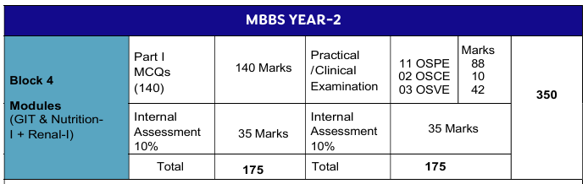
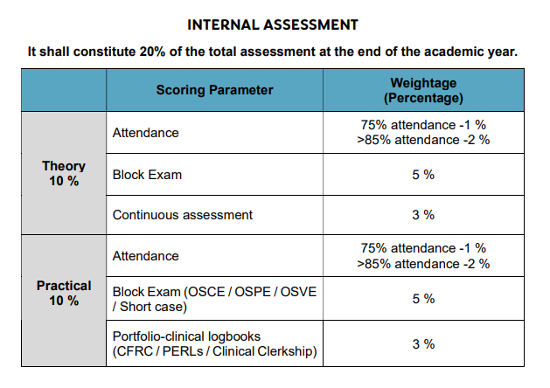

Assessment Schedule:

Avicenna Medical College
2nd Year MBBS – Exam Schedule – 2026/27
Week # | Date | Exam
3 | 20/4/26 to 24/4/26 | Tutorial Test
4 | 29/4/26 | Integrated Formative Assessment – 01
5 | 4/5/26 to 8/5/26 | Tutorial Test
6 | 11/5/26 to 15/5/26 | Tutorial Test
7 | 21/5/26 | Module – 06 (Theory + OSPE/OSVE)
9 | 8/6/26 to 12/6/26 | Tutorial Test
10 | 17/6/26 | Integrated Formative Assessment – 02
11 | 24/6/26 | Allied Subjects Integrated Formative Assessment – 01
12 | 2/7/26 | Module – 07 (Theory + OSPE/OSVE)
13 | 6/7/26 | Block – IV (Theory)
13 | 7/7/26 | Block – IV (OSPE / OSVE)
15 | 17/8/26 to 21/8/26 | Tutorial Test
16 | 24/8/26 to 28/8/26 | Tutorial Test
17 | 31/8/26 to 4/9/26 | Tutorial Test
18 | 9/9/26 | Integrated Formative Assessment – 03
20 | 23/9/26 | Integrated Formative Assessment – 04
21 | 30/09/26 | Module – 08 (Theory + OSPE/OSVE)
23 | 12/10/26 to 16/10/26 | Tutorial Test
24 | 21/10/26 | Integrated Formative Assessment – 05
25 | 28/10/26 | Allied Subjects Integrated Formative Assessment – 02
26 | 2/11/26 to 6/11/26 | Tutorial Test
27 | 11/11/26 | Module – 09 (Theory + OSPE/OSVE)
28 | 16/11/26 | Block – V (Theory)
28 | 17/11/26 | Block – V (OSPE / OSVE)
30 | 30/11/26 to 4/12/26 | Tutorial Test
31 | 7/12/26 to 11/12/26 | Tutorial Test
32 | 16/12/26 | Integrated Formative Assessment – 06
33 | 28/12/26 to 1/1/27 | Tutorial Test
34 | 6/1/27 | Integrated Formative Assessment – 07
35 | 13/1/27 | Module – 10 (Theory + OSPE/OSVE)
35 | 18/1/27 | Allied Subjects Integrated Formative Assessment – 03
36 | 21/1/27 | Module – 11 (Theory + OSPE/OSVE)
36 | 25/1/27 | Block – VI (Theory)
36 | 26/1/27 | Block – VI (OSPE / OSVE)

Table of Specification
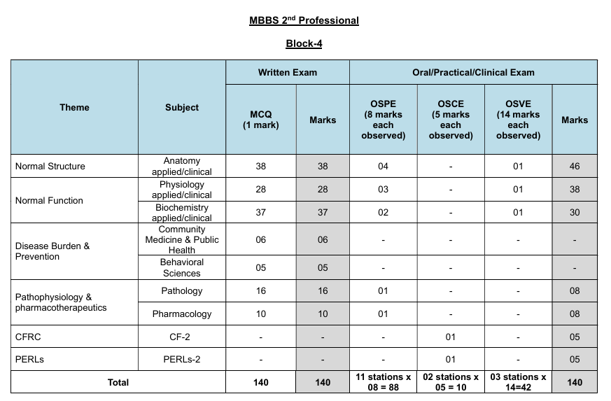

Recommended Books & Reading Resources
Anatomy
Snell’s Clinical Anatomy 10th edition.
Langman’s Medical Embryology 12th edition
Medical Histology by Laiq Hussain Siddiqui 8th edition.
General Anatomy by Laiq Hussain Siddiqui 6th edition.
Biochemistry
Harpers illustrated Biochemistry (latest edition). Rodwell.V.W MCGrawHill publishers.
Lippincott illustrated Review (latest edition). Kluwer.W.
Essentials of Medical Biochemistry vol 1&2 by Mushtaq Ahmed.
Pathology
Vinary Kumar, Abul K. Abbas and Nelson Fausto Robbins and Cotran, Pathologic basis of disease. WB Saunders.
Robbins and Cotran Pathological Basis of Disease. Kumar, V., Abbas, A. and Aster, J. Latest Edition
Richard Mitchall, Vinary Kumar, Abul K. Abbas and Nelson Fausto Robbins and Cotran, Pocket Companion to Pathologic basis of diseases, Saunder Harcourt.
Walter and Israel. General Pathology. Churchill Livingstone.
Robbins & Kumar, Medical Microbiology and Immunology Levinson.
General Medicine
Principles and Practice of Medicine by Davidson (latest edition)
Clinical Medicine by Parveen J Kumar & Michaell Clark
Oxford Handbook of Medicine
Macleod's Clinical Examination book
Medicine and Toxicology by C.K. Parikh
Hutchison's Clinical Methods by Michael Swash. 21st edition
Pharmacology And Therapeu cs
Katzung and Trevor’s Pharmacology: Examination and Board Review- 15th Edition
Basic and Clinical Pharmacology by Bertram G Katzung (case scenarios only) - 16th Edition-
Current Medical Diagnosis and Treatment- reference book –Edition-2024
Basic and Clinical Pharmacology by Bertram G Katzung (case scenarios only) - 15th Edition
Basic and Clinical Pharmacology by Katzung, McGraw-Hill. 16th Edition.
Pharmacology by Champe and Harvey, Lippincott Williams & Wilkins 8th Edition.
Katzung Basic and Clinical pharmacology, Lippincot Illustated reviews.
Clinical Pathology Interpretations by A. H. Nagi
Behavioural Sciences
Handbook of Behavioural Sciences by Prof. Mowadat H.Rana, 3rd Edition
Medical and Psychosocial aspects of chronic illness and disability 6th edition by Donna R.Falvo and Beverely E.Holland,
Integrating behavioral sciences in healthcare, Asma Humayun,2003, 1st edition
Community medicine
Parks Textbook of Preventive and Social Medicine. K. Park
Public Health and Community Medicine by Ilyas Ansari
MSDS manual of Government of Punjab
Textbook of Community Medicine by Park J E. Latest Edition
Surgery
Bailey & Love’s Short Practice of Surgery (latest edition)
Browse's Introduction to the Symptoms & Signs of Surgical Disease 4th Edition
Bailey & Love Short Practice of Surgery, Clinical Surgery pearls by Dayananda Babu RACS for Surgical Audits.
Patent Safety
Patient Safety Curriculum Guide: Multi Professional Guide
Microbiology
Levinson’s review of Microbiology
Medical Microbiology and Immunology by Levinson and Jawetz,
Pediatrics Medicine
Nelson Textbook of Pediatrics
Basis of Pediatrics by Pervez Akbar Khan
Gynecology
Gynecology by Ten Teachers
Infection Control
National Guidelines Infection Prevention and control, National Institute of Health Pakistan
Biosafety
Biosafety in Microbiological and Biomedical Laboratories, 6th Edition (CDC, USA)
WHO Laboratory Biosafety Manual, Fourth Edition, And Associated Monographs
WHO safe management of wastes from healthcare facilities chapter 7 -8 page 77-99, 105-125)
Family medicine
Oxford Handbook of General Practice, 5th Edition
Orthopedics
Apley and Solomon's System of Orthopaedics and Trauma by Ashley Blom (Editor)
Rheumatology
Davidson's Principles and Practice of Medicine
Clinical Medicine by Parveen J Kumar & Michaell, Clark
Hutchison's Clinical Methods by Michael Swash
Radiology
Aids to Radiological Differential Diagnosis by Chapman S. and Nakielny R. 4th edition.
Elsevier Science Limited; 2003.
Forensic Medicine
Knight’s Forensic Pathology by Barnard Knight 3rd edition
G. Principles and Practice of Forensic Medicine by Prof. NasibR. Awan,2nd edition
Forensic DNA Typing – 2nd Edition, Author: John M. Butler
Parikh’s Textbook of Medical Jurisprudence, Forensic Medicine and Toxicology by C.K. Parikh 6th Ed., CBS Publisher.
Gun Shot Wounds 2nd edition by V.J.Deimaio
Knight B. Simpson’s Forensic Medicine.
Knight and Pekka. Principles of Forensic Medicine
Forensic Pathology
Forensic pathology 2nd edition by V.J.Deimaio CRC press Boca Raton London New York
Washington DC
Toxicology
Principles of clinical toxicology 3rd edition Thomas. Gossel CRC press Taylor and Francis group
Forensic Sciences
Fundamentals of Forensic Science- 3rd Edition: Author: Max M Houck, Jay A. Siegel
TextBook of forensic medicine and toxicology Principles and Practice 5th edition by Krishan Vig
Biomedical ethics
Principles of Biomedical ethics, 8th edition by Tom. L. Beauchamp, James F. Childress.
Evidence Based Medicine
Databases for the latest articles/manuscripts
Clinical Practice Guidelines- local and international - (within last 3 years)
Books (Latest edition-within last 5 years)
Pediatrics
Nelson's Book of Pediatric 22 edition Illustrated book of Pediatrics, Pervaiz Akbar textbook peads medicine
Islamiyat
Standard Islamiyat (compulsory) for B.A, BSc, MA, MSc, MBBS by Prof M Sharif Islahi.
IImi Islamiyat(compulsory) for BA, BSc & equivalent.

Infrastructure Resources

Sr. | Infrastructure Resources | Description
1. | Lecture Hall | Each year has a dedicated lecture hall, totaling five lecture halls for the five professional years. These halls are equipped with modern audiovisual aids to support effective teaching and learning.
2. | Tutorial Room | The college's tutorial rooms, each with a capacity of 30, are specifically designed to support small group discussions and interactive sessions. These rooms facilitate personalized instruction, enabling more engaged and effective learning through direct interaction between students and instructors.
3. | Lab | The college is equipped with state-of-the-art laboratories for practical and clinical work. Each lab is designed to support various disciplines, to facilitate hands-on learning.
4. | Library on campus | A huge library occupies a full floor and has 260 seats including study carrels and group-discussion tables. Latest reference books of Basic and Clinical Sciences along with national & international journals are available in the library.
5. | Digital Library | The digital library offers access to a vast collection of e-books, online journals, research databases, and other digital resources. It supports remote access and provides tools for academic research and learning.
6. | Learning Management System (LMS) | The LMS is a comprehensive online platform that supports course management, content delivery, student assessment, and communication. It provides tools for tracking progress, managing assignments, and facilitates ongoing academic activities.
6. | Phantom Labs | Specialized Phantom Labs are available for advanced simulation and practice in dental procedures. These labs provide high-fidelity models and simulators that help students refine their clinical skills in a controlled environment.
7. | Mess & Cafeteria | The College has its own on-campus Mess which caters to 600 students. All food items including dairy, meat, and vegetables are sourced organically and bought in at the time of cooking, in order to ensure that students get freshly cooked meals at all times  Students form the Mess committee which decides the mess menu in consultation with other students. The Mess offers fresh food to all residents three times a day. However, day scholars are also welcome to use the Mess facility at a reasonable cost.  Two 50- inch LCD screens provide students an opportunity to get entertained during their meal times.
8. | Gymnasium & Sports | We recognize sports as a pivotal key to shape and maintain students' personality and good health. The College has indoor and outdoor sports facilities to help enhance the cognition and capacity to learn. There is a proper sports section for various games like basketball, football, volleyball, and cricket.  The gym itself is fully equipped with modern machinery both for students and faculty.
9. | IT Lab | The IT Lab is equipped with modern computers and software available for students who need access for academic purposes.
10. | Auditorium | The college has a spacious auditorium equipped with advanced audio-visual facilities. It is used for large-scale lectures, guest presentations, and academic conferences, providing a venue for students to engage with experts and participate in important educational events.
11. | Examination Halls | The college provides dedicated examination halls that are designed to accommodate a large number of students comfortably. These halls are equipped with necessary facilities to ensure a smooth and secure examination process, including proper seating arrangements, monitoring systems, and accessibility features.

